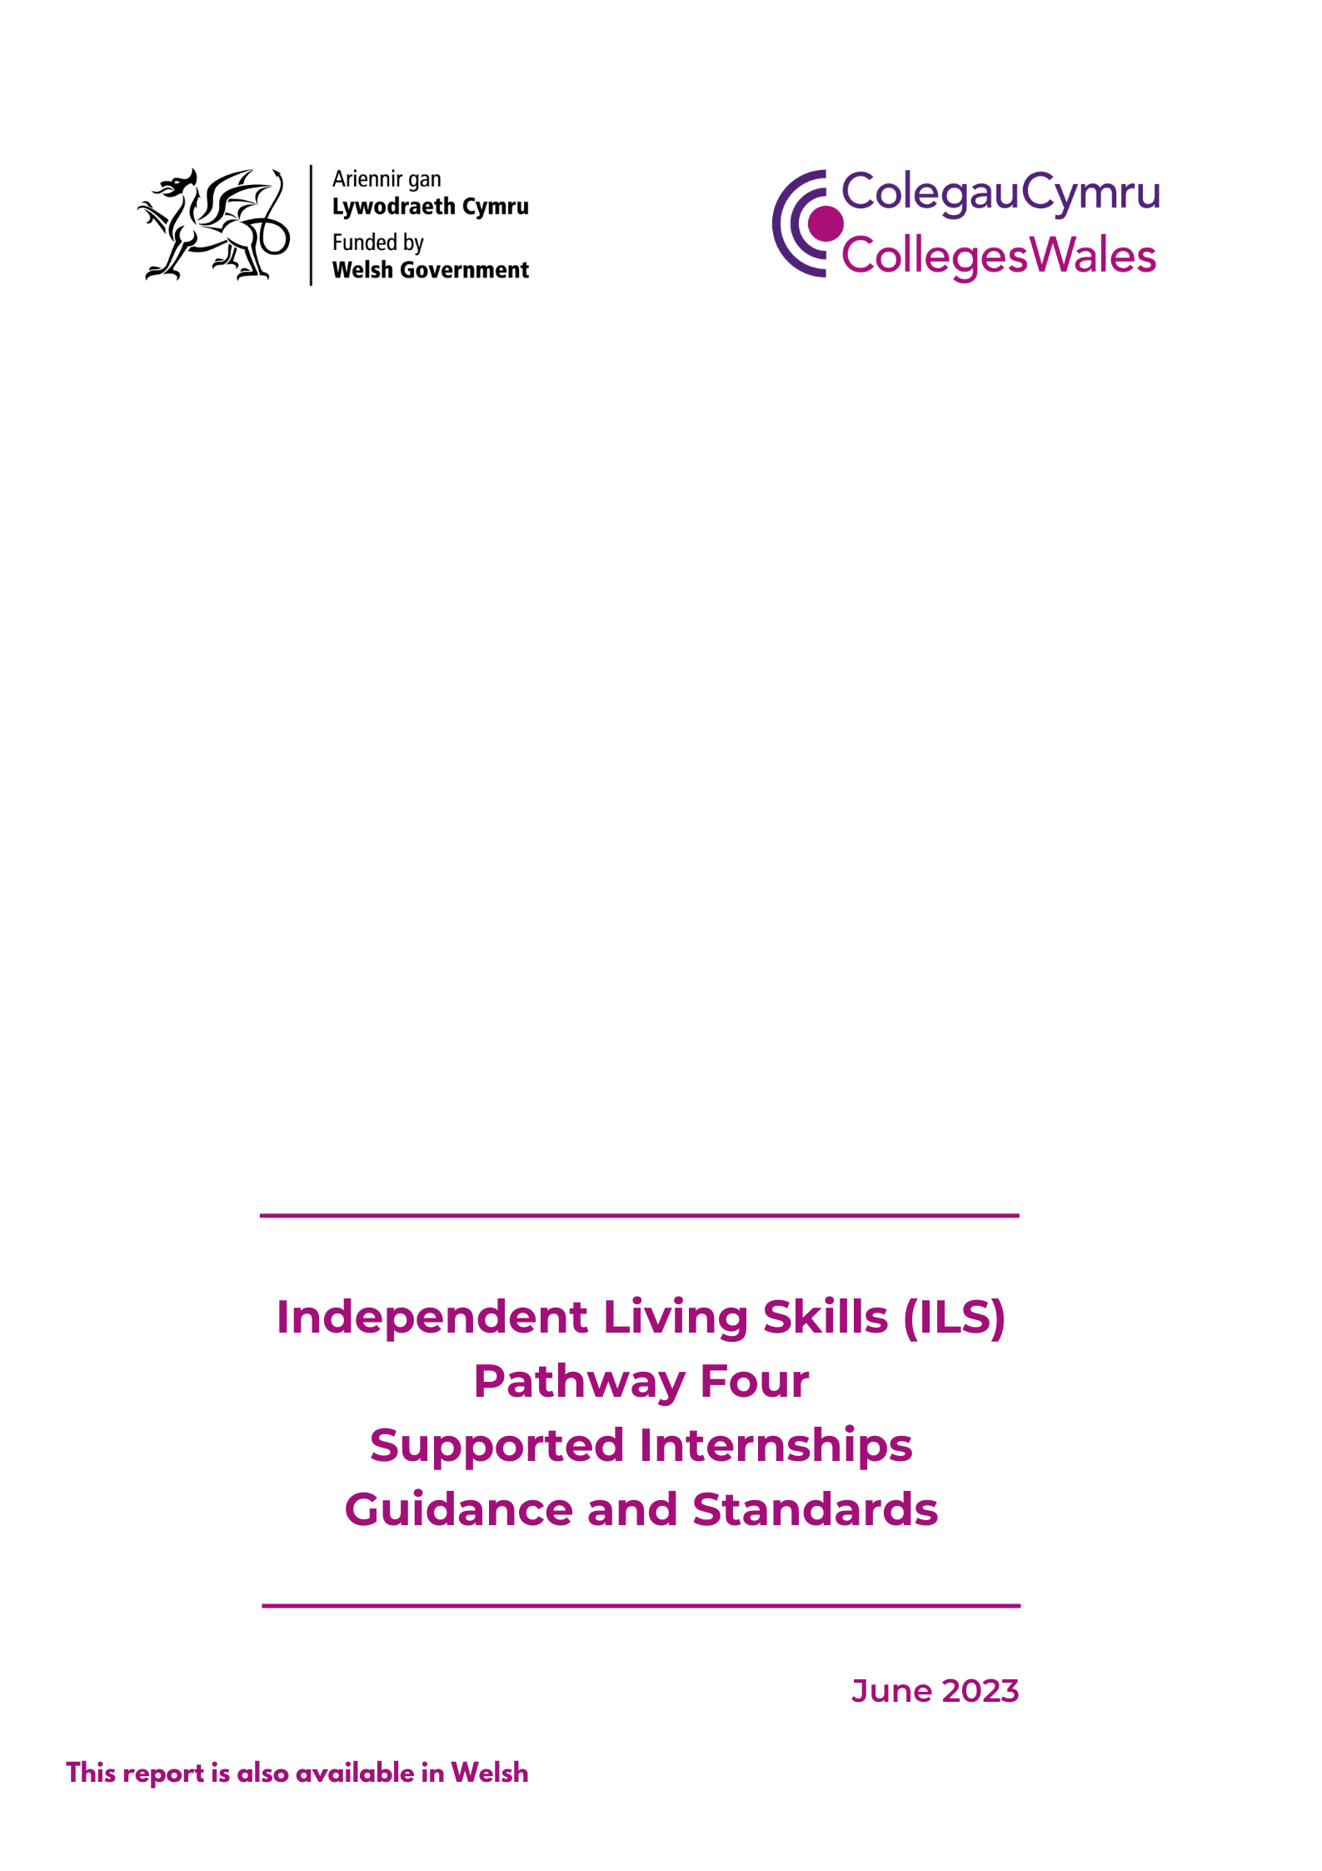

Table of Contents

1. Introduction 3
2. Pathway 4 2.1 What is Pathway 4? 3
2.2 Pathway 4 and Supported Internships 3
2.3 Differences between ILS Pathway 3 and 4 programmes 4
2.4 Learner profile 4
2.5 Terminology 4
3. Aims and benefits of Pathway 4 programmes 4
3.1 Aims of Pathway 4 programmes 4
3.2 Benefits for learners, employers and all involved 4
3.3 Case Studies 5
4. Principles for Pathway 4 programmes 5
5. Setting up provision - Pathway 4 Delivery Model Flowchart 6
5.1 Factors to consider 6
5.2 The essentials of a Pathway 4 programme 1
5.3 Employment hours 2
5.4 Progression to work 2
5.5 Communication, numeracy and digital literacy 2
5.6 The place of qualifications 2
6. Partnerships, Key Stakeholders and Collaborative Working 3
6.1 Roles and Responsibilities: host businesses 6
6.2 Roles and responsibilities: the college 6
6.3 Roles and Responsibilities: supported employment agency 8
7. Learner recruitment 9
7.1 Work readiness 9
7.2 Information gathering 9
7.3 Recruitment - Case Study - Grŵp Llandrillo Menai 9
8. Progression 10
8.1 Progression to full time, part time employment and the place of unpaid or voluntary work 10
8.2 Progression to supported apprenticeship schemes 11
9. Funding and the benefits system 11
9.1 Welsh Government programme area funding 11
9.2 Better Off in Work calculations and welfare benefits 12
9.3 Department for Work and Pensions/Access to Work 12
9.4 Who can get Access to Work grants? To be eligible for support, a person must: 12
9.5 Disability confident and other schemes 13
10. Pathway 4 and quality assurance 13
11. Memorandum of Understanding (MOU) 14
12. Useful documents and templates 14

1. Introduction
This document provides information about Independent Living Skills (ILS) Pathway 4 programmes (including supported internships) for Further Education (FE) providers in Wales. It offers guidance for those who are setting up or delivering Pathway 4 programmes by providing information on:
- aims and benefits of the programme for learners
- essential programme components
- funding and the benefit systems
- partnerships and collaborative working
- staffing and staff roles
The guidance has been developed by the ColegauCymru ILS pathway 4 (supported internship) working group, with membership that includes experienced representatives from; all FE institutions in Wales, Project Search, Engage to Change, Elite, Estyn and Welsh Government. Members of the group include those who have been running successful supported internships programmes, to support young people with additional learning needs into employment.

2. Pathway 4
2.1 What is Pathway 4?
Pathway 4 has been developed as part of the Independent Living Skills (ILS) programme area curriculum, to support learners with learning difficulties and/or disabilities to achieve sustainable paid employment. This is achieved by combining workplace-based learning with a personalised study programme which includes elements from the ILS curriculum. The focus of the programme is to equip learners with the relevant skills and qualifications that they will need for employment in their chosen area. Communication, numeracy and digital literacy skills are a key part of learning, with opportunities to develop and practise these skills both within the workplace and embedded within each of the ILS curriculum four pillars of learning.

2.2 Pathway 4 and Supported Internships
Pathway 4 includes, but is not limited to, provision for learners on supported internship programmes. The pathway allows for colleges to set up their own models, providing they fit the Pathway 4 criteria and the standards set out in this document.

2.3 Differences between ILS Pathway 3 and 4 programmes
There are important differences between these two pathways; Pathway 3 offers preparation for Pathway 4 and other college programmes. Pathway 3 includes on-site social enterprises and although learners may take part in work experience, they do not spend most of their time at an employer’s premises. Pathway 4 learners will rarely be in college; the programme recognises the importance of setting and reinforcing new habits in getting to and from work on a regular basis, as well as gaining on-the-job skills.

2.4 Learner profile
Learners on Pathway 4 will, typically, be aged between 16 and 25, and come from a variety of backgrounds. All will have a diagnosis of a learning disability /difficulty and/or autism. Learners will also need to have a mature attitude, be willing to learn and develop their skills and be dedicated to finding employment. Many of the learners will have progressed from Pathway 2 and 3; this will be the ‘final year’ for learners who are able to progress into paid employment.

2.5 Terminology
The wording ‘learning difficulties and/or disabilities’ is terminology specifically used in education; this differs from social services and health terminology where the equivalent term is ‘learning disability’. The Welsh Government would not expect learners from a mainstream programme to access Pathway 4 programmes.

3. Aims and benefits of Pathway 4 programmes

3.1 Aims of Pathway 4 programmes
To prepare young people with learning difficulties/disabilities for paid employment by;
- Supporting them to develop skills valued by employers
- Enabling them to demonstrate their value in the workplace
- Developing confidence in their own abilities to perform successfully at work

3.2 Benefits for learners, employers and all involved
Pathway 4 and supported internship projects have been shown to provide enormous benefits for all concerned:
- Learners gain confidence, skills and independence.
- They become competent in carrying out their role, familiar with the work environment and staff.
- They learn that they have the potential to be employed.
- For many employers the projects break down barriers and challenge assumptions about disabilities. In many cases attitudes change as employers realise that the intern can do the job and has the potential to become a valued employee.
- Parents and carers see that employment is a realistic possibility and have the chance to let go gradually over a year as they watch the learner grow and develop in a safe and supported environment. Pathway 4 programmes provide a vital transition from college into the workplace.

3.3 Case Studies
Grŵp Llandrillo Menai/Engage to Change/Project Search
https://www.youtube.com/watch?v=T6wpmMGyUTY

4. Principles for Pathway 4 programmes
Pathway 4 programmes will vary according to local circumstances and learner needs. However when setting up a new programme the following principles should be considered. These principles have been adopted from the DfE Guidance on Supported internships.

- A significant majority of the supported intern’s time is spent at the employer’s premises in a work placement. Whilst with the employer, the young person will be expected to comply with real job conditions, such as timekeeping, shift patterns and dress code.
- Supported interns follow a personalised study curriculum alongside their time with the employer, including relevant aspects of communication, numeracy and digital literacy. This will be an individualised package that is delivered by the provider and should support their progression to paid employment. It should give the supported intern the opportunity to reflect on their learning journey.
- Job coaches are central to the study programme and provide support to both the young person and employer. They should be trained in line with the national occupational standards for supported employment.
- The primary goal of the programme for the young person is paid employment. Work placements must work for both the young person and the employer.

For the young person, the job must fit with their vocational profile, contribute to their long-term career goal and be flexible enough to address barriers where necessary.

For the employer, they should meet a real business need. The employer should be committed to supporting the young person towards paid employment.

5. Setting up provision - Pathway 4 Delivery Model Flowchart
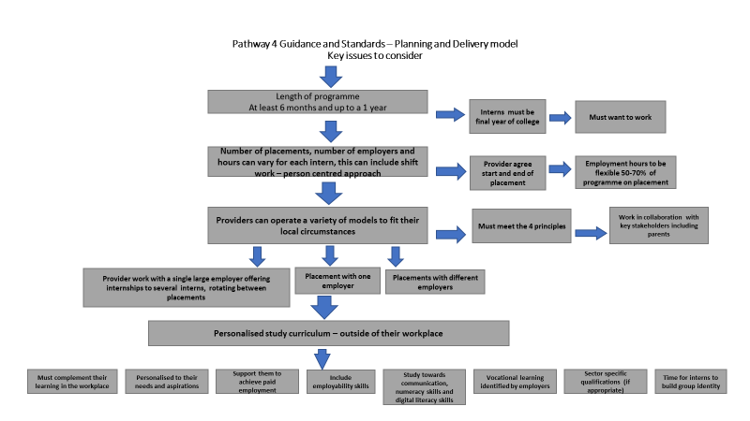

5.1 Factors to consider
Colleges can design and set up Pathway 4/ Supported internship programmes to fit the local environment as well as to meet learner needs. Factors that determine the type of programme will include the range of suitable employers within the local area, the degree of rurality and the needs and numbers of learners who are ready to take part in the programme. Colleges need to allow sufficient lead in time when developing new programmes. They need to be aware that it will take considerable time to make the links with employers and supported employment agencies, to set up agreements, to recruit and train staff, to advertise the programme and to recruit learners.

5.2 The essentials of a Pathway 4 programme
Pathway 4 programmes must include:
- A person-centred process throughout the programme including:
- Person centred planning at the start of the learner’s individual programme, which identifies aspirations and interests; assesses a learner’s existing strengths and agrees realistic targets for relevant skills development for successful employment. There are some useful vocational profiling resources that can be found on the Preparation for adulthood site.
- Person centred reviews throughout the programme that provide an opportunity for the learner to voice what’s working/not working; identifies progress made, amends targets and celebrates achievement.
- A destination led focus The aim of this programme is to provide a route to paid employment for learners with learning difficulties/disabilities. A learner’s programme should start with this end in mind, to begin by considering learner aspirations and interests and converting these into realistic employment possibilities. The employment placement should be chosen to match these so that the learner has the skills to progress smoothly into paid employment.
- Employment based learning Learners recruited onto Pathway 4 programmes will attend for at least 6 months and up to a year. Providers will not be penalised if supported interns complete a supported internship earlier to take up paid employment. Learners must be engaged in meaningful work for a significant majority of this time at the employer’s premises where they will be expected to comply with real job conditions. Learners may need to be in college during an induction and assessment period but this should be for a minimal amount of time, with a move to being based at the workplace by the end of the first half term. The aim is to develop and embed work routines to provide confidence and competence in accessing and maintaining employment.
- Providing support During the programme learners must have a job coach to support them directly in the workplace, identifying their skills, strengths and areas for development. Continuity of support should be available to develop strong relationships and break down barriers. The amount of support will differ, depending on the needs of each intern. However, as a general principle, the support provided should enable the intern to be as independent as possible. The level of support required may change if there is a change in interns’ responsibilities, they move to another role, or the situation in the workplace changes e.g. new colleagues, manager or rota.
There should be a clear communication process, with written, easy read information given to internees regarding length of placement; who their job coach will be and how to contact them.

5.3 Employment hours
These should be set flexibly and be person-centred. Hours can be increased to suit the individual. 50 - 70% of the hours on the programme should be spent in employment.

5.4 Progression to work
There should be the possibility for paid employment for the learner at the end of the programme. This may be with the work placement organisation or within the open jobs market. The programme must also provide opportunities for learners to:
- Gain experience at work for their CV showing that they have the skills and willingness to work.
- Practise and improve independence skills including, where appropriate, independent travel to and from the workplace.

5.5 Communication, numeracy and digital literacy
Programmes should include opportunities for learners to make progress on individual targets that develop and improve their employability skills, communication, numeracy and digital literacy skills. Learning should be contextualised to the employment situation and, where possible, embedded in the programme.

5.6 The place of qualifications
Pathway 4 is a non-accredited programme. There may, however, be occasions where including accreditation is appropriate. Accreditation or qualifications should only be used when it is right for the learner, for example where:
- it will help them meet person specification for a job e.g. Food Hygiene Skills accreditation for working in hospitality and catering;
- it allows them to demonstrate suitability for a job role in a way the employer recognises; or
- it provides motivation.
Before including accreditation/qualifications ask; ‘How will this move the learner to achieving their outcomes?’

6. Partnerships, Key Stakeholders and Collaborative Working
A successful Pathway 4 programme involves partnership working. The main goal is successful transition into employment and collaborative working is key to achieving and sustaining this for learners. Partnerships can include the host business, the college and a supported employment agency. Involvement of parents and carers is also crucial, they need to fully understand both the process and the outcome to support the young person through the course and into employment. Depending on the design and setup of the programme, several key roles, often delivered by several partners, are essential. Partners will generally offer insight and specialisms to enhance programme delivery and quality.

Case Study - Working with the local council and small businesses in the area to set up non-accredited supported internships
Coleg y Cymoedd
The Gateway to Employment course being delivered at Coleg y Cymoedd, recruits up to 10 internees who have already completed a year in college on a preparatory ILS Pathway 3 programme.
The course has been designed to be the learner’s final year in education providing the opportunity for transition into the workplace. The aim is to help learners secure paid employment at the end of the year.
The strong partnership between the college, RCT County Borough Council and Engage to Change is key to the success of the project; Coleg y Cymoedd links with RCT Council, Caerphilly Council, and other small businesses throughout RCT, Caerphilly and Cardiff areas to access internships for the learners. Job coach support is provided by ELITE supported employment agency, who continue to deliver the programme with the college and RCT County Borough Council, following withdrawal from Engage to Change due to the project ending.
‘At the start of the project, we held monthly meetings to create a MOU and plan the implementation and delivery model of the Internship. It was felt by all involved that there needed to be flexibility built into the model, so that it was always person centred and followed the supported employment model. The focus is around ensuring that all the interventions provided meet the individuals needs and that the hours reflect their capabilities, stamina and well-being, with an emphasis on ensuring an appropriate job match for the Intern.
There is close collaborative working between the employer, RCT County Borough Council, ELITE supported employment agency, and the college to ensure that all the interns gain a range of employability skills and become independent. If paid work could not be secured, then the young person was referred to the wider Engage to Change project to receive specialist support through ELITE to find paid employment or undertake volunteering if needed.’
The course runs for a full academic year, from September to June. The interns complete 2 days a week in college, September to October, then one day a week from November to June. The interns are on placement for between 4 and 16 hours, over several days for the remainder of the week. Placement hours are determined by the learner’s individual needs and the business needs of the employer.
https://www.youtube.com/watch?v=qyHmKpLs3kU

Partnerships
Case Study - Working with DFN Project search - an accredited approach
Cardiff and Vale College
Cardiff and the Vale College have worked for several years in partnership with DFN Project Search to provide two supported internship programmes, with host businesses Cardiff University and DOW Silicones UK Limited. The programmes, each with ten learners, run over 34 weeks with learners attending the host business sites for 4 to 16 hours per week (tailored to learner and business need) Monday to Friday. Learners follow an intensive transition process onto the course in the summer before they start. Both host businesses provide a base room as well as mentors for the learners.

Staffing
- 1 Instructor/Tutor (full time)
- 1 Job Coach (full time)
- 1 Job Developer (full time /shared role)

A typical day for a learner would run as follows:
9.00am Check in and Instruction
10.00am Systematic instruction and employee mentor placement (3 rotations over the academic year)
3.00pm – 4.00pm Check out and reflection/planning.

Both programmes follow an accredited curriculum, with learners achieving a Level 1 Extended Certificate, Agored Cymru, in Work Related Education; however CAVC are reviewing the use of this accreditation and considering a more person-centred approach based on individual needs, with more time dedicated to the personal development of the interns. The review has shown that a Level 1 qualification is not recognised by local employers, when employing people for entry level jobs. CAVC have identified that a non-accredited approach is likely to fit better with learning priorities in a workplace. (This now follows a non-accredited curriculum using RARPA*). The key driver is to secure employment for interns and provide them with the personal and employability skills to reach that goal. Learners will continue to enrol on industry related additional courses where this is relevant for the roles that they are carrying out e.g. First Aid, Food Hygiene, Forklift Truck CSCS etc.

Successes
- 45% (on average over the 2 sites) achieve paid sustainable employment
- The programme provides real-life work experience, with consistency, structure, and expectations of being in the workplace. Interns are seen and treated as employees, and this is reinforced across the organisation.
- All interns will have a better understanding of the workplace and what is available to them in their locality.

Some of the lessons learned from the programme
- Interns develop at their own pace and interns require time to process their practical skills gained in their internships through to recognising the transferable skills they have gained, primarily through formative and summative assessment.
- A small collaborative operational working group is more effective in meeting the day to day needs of the interns and business.
- A positive engaging and fully immersive host business is critical to the success of the programme, which enhances the intern's experience.
- Shared cross sector skills and experiences amongst partners provides valuable insight and learning for each to move the programme forward.
- Specific training for the host business and its mentors and managers is valuable, particularly task analysis, systematic instruction, working and supporting a young person with an ALN.
- The DFN Project Search programme can change the culture of the host business and meet corporate social responsibility objectives.

An example of the CAVC Supported internship learner journey

*RARPA - Recognising and Recording Progress and Achievement.

6.1 Roles and Responsibilities: host businesses
Multiple businesses from the public and private sector can be targeted in respect of offering internships opportunities within different sectors. Their role in the partnership is to:
- Assist with the needs analysis for the interns to be prepared for their placement.
- Inform the workplace staff/managers of the aim of the programme and expectations for interns
- Assist with the identification of job opportunities for interns.
- Adapt the workplace in accordance with recommendation (no additional costs should be incurred)
- Allow the College/supported employment agency staff access to the site/workplace to liaise with the relevant employer contacts.
- Provide resources and rooms for taught sessions, if appropriate e.g. Hospital setting.

6.2 Roles and responsibilities: the college
- Draw down programme funding from Welsh Government.
- Offer a dedicated member of staff to coordinate the programme and offer tuition according to the agreed curriculum.
- Produce a suitable curriculum with elements being accredited if it supports progression.
- Select staff to mentor the interns progress by regularly liaising with the employers.
- Organise and participate with other stakeholders in the selection process of interns.
- Facilitate family involvement.
- Assist interns with planning travel arrangements to work.
- Organise additional support for individual interns (if necessary).
- Provide resources and rooms for taught sessions within the college for interns (if necessary).
- Assist with the arrangements and risk assessment of the internship opportunities.
- Coordinate regular meetings to evaluate the programme/intern performance responding positively to agreed action.
- Promote the programme.
- Assist with the progression route for interns to paid work.
- Supply IT equipment for interns for work related activities as well as a means of communicating with college staff.

Tutor/Assessor This role would ordinarily be an employee of the college and would take on the role of personal tutor, delivering any accredited or non-accredited learning provision and the assessment, monitoring and tracking of student progress against outcomes.
- The Tutor/Assessor would have responsibility for identifying and recruiting suitable students onto Pathway 4, and would work closely with the Job Coach to deliver skills profiling, travel training and induction support to students.
- The Tutor/Assessor would work closely with parents/carers, enabling them to understand the benefits of Pathway 4 provision and to champion the intended destination for each student into sustained paid employment.
- Day-to-day, the Tutor/Assessor works alongside the Job Coach and key members of staff within the employment setting, working to identify further opportunities, tracking and monitoring student progress and working to enhance learning and role responsibilities for students.

6.3 Roles and Responsibilities: supported employment agency
- Provide a manager/supervisor to coordinate the planning – to include selecting candidates and agree curriculum framework.
- Provide job coaches and employment officer/s to work with the employers (supporting interns and assisting with monitoring of progress).
- Work with employers to find suitable internship opportunities.
- Provide advice and assist with adaptation of accommodation for interns in the workplace (if required).
- Promote the concept of internships to the host business as the best way to support the interns on the programme.
- Attend meetings responding positively to agreed actions.
- Produce a risk assessment for interns when attending the workplace.
- Be involved with the planning and promotional activities linked to the programme.
- Assist with the Progression to work.

Job Coach
- Role might be employed by the college or delivered by a supported employment. agency, either commissioned by the college or as part of a wider project funding agreement.
- The role is essential in working with students to profile skills, strengths and areas of development.
- The job coach will be responsible for identifying role opportunities within a place of employment and working to understand the tasks and responsibilities required for each of the roles identified.
- A job coach would spend the majority of their time working directly with students out in the workplace, helping to remove barriers to accessing tasks and working to support employees within the department or area of work that the student is working in.
- The job coach will work collaboratively with the tutor/assessor to monitor and record progress against targets and to add further responsibilities or tasks into the daily / weekly routine of the student to enhance learning and development within the role.
- Job coaches should be trained in line with the national occupational standards for supported employment.
Employer liaison partner
When working with an employer, it is important to identify a lead contact who is able to support key activities. This role will generally broker conversations with senior leaders within an organisation and help to influence and leverage change, remove barriers and identify opportunities. The types of activities this role might support with include:
- Working with department leads to identify roles for students
- Providing access to induction and health and safety training and resources
- Identifying and providing any resource requirements, including space, uniform or access to IT systems

7. Learner recruitment

7.1 Work readiness
Learners can be recruited onto Pathway 4 programmes directly, or as progression from other ILS programmes first. Many will have followed Pathway 2 or Pathway 3 programmes to prepare them for the step into employment. Learners need to be ‘work ready’ before applying, with both an attitude of wanting to work and sufficient social and independence skills to enable them to thrive and survive in the workplace.

7.2 Information gathering
Gathering as much information about the learner before they start on the course is essential. This should be carried out in a person-centred way with the learner fully always involved. Information gathering will also help identify whether a learner is ready for a Pathway 4 programme and will identify learner needs and help with job matching. Entry to a programme should be determined by information gathered from a range of sources. A successful interview (tailored to interviewee needs), which may include practical assessments and use of scenarios should also be part of the recruitment process. The process should be two way with learners having a clear understanding of what the course will entail. This could include site visits and taster sessions in the workplace.

7.3 Recruitment - Case Study - Grŵp Llandrillo Menai
Getting ready for placement
“Candidates for Pathway 4 programmes follow an Independent Living skills programme of learning before applying. Interns may have followed Pathway 2 or 3 programmes such as Step up to Work before applying for the Supported Internship programme. The recruitment process also includes information gathering, an interview process; this includes practical systematic instruction tasks followed by a formal interview which include scenarios. Following recruitment learners are invited for site visit where all risk assessments, occupational health forms and DBS are completed.”

“Once their initial assessment period has come to an end, work begins on the interns’ profiles. This is filmed once the interns are comfortable with what they want to say about themselves. They are assisted in creating an interesting and engaging presentation about themselves where the one-page profile filmed is a part of that and then it is shared with departments where the interns are placed. This way, departments have an insight of the personality that they are getting, and they can plan beforehand on how best to support individuals whilst they are placed at their departments.”

“The parents/guardians are encouraged to be an important part of the project from the very beginning. The team will be in regular contact with them all through the project, allowing the personal and professional development of their son/daughter to continue when they leave us at the host business. The targets set for their son/daughter are shared with the parents/ guardians so that they are aware of the areas where their son/daughter needs to develop, change or adapt.”

Diya Banerjee One Page Profile on film.

8. Progression

8.1 Progression to full time, part time employment and the place of unpaid or voluntary work
The progression route for most supported interns is directly into paid employment. This may be full time or for part time hours, depending on individual circumstances, and offering realistic routes out of college and into adult life. Occasionally interns move on to unpaid or voluntary work; however, this is not the aim of the programme and should be considered only as a temporary progression step.

8.2 Progression to supported apprenticeship schemes
A small minority may wish to consider progression to a Supported Apprenticeship or Supported Shared Apprenticeship upon completion of their internship programme. To do this they need to meet the entry criteria and have the ability to achieve a minimum level 2 qualification in their chosen occupation / sector, as part of their apprenticeship. Fair access to assessment and job coach support can also aid this outcome requirement.
Providers should work with the interns to ensure that a transition plan is in place, so that each young person has a positive progression route planned. This includes a conversation with the host employer to see if there is a vacancy and how they should apply. Providers should also support the intern to develop and practise the skills needed in applying for the job e.g. building a CV, filling in the application form, interview skills. Supported apprenticeships provide intensive support to apprentices with wide-ranging additional employment and learning needs to complete an apprenticeship. Support provided may be through job coaching or other specialist resources. Supported shared apprenticeships also provide wage contributions and supported placements to enable the apprentice to meet the framework requirement across a range of host employers.

Case Study - Internships Nevill Hall Hospital

9. Funding and the benefits system

9.1 Welsh Government programme area funding
In the academic year 2021/2022 Welsh Government introduced a single funding rate of £10,995 for all full-time Independent Living Skills (ILS) delivery. This was introduced following a review of funding of the ILS learning area, which took place between November 2019 and January 2020. This new funding rate reflects the average cost of delivering ILS programmes across the sector and is based on the costs for core teaching and learning staff together with uplifts for running costs and other college overheads. Costings submitted by ColegauCymru ILS Network members in 2022 indicate that this will cover the cost of a tutor and a job coach for a group of 10 learners on a Pathway 4 programme. Further information regarding Welsh Government funding is published in the Welsh Government ILS programme area specifications. A copy can be found on the Padlet.
Ideally there should be a tutor (Lecturer/instructor) and two job coaches to support a group of ten learners. Access to Work funding could be used to fund the second Job Coach role.

9.2 Better Off in Work calculations and welfare benefits
It is essential to establish which welfare benefits a young person is receiving prior to them commencing any form of Supported Internship. Whilst some people attending college may only be in receipt of Personal Independence Payment, and others Universal Credits, the financial impact of employment must be considered to avoid any form of financial detriment to the intern when planning or entering employment. A Better Off in Work calculation can be conducted by the Supported Employment Agency linked to the internship at the point of Vocational Assessment. This will provide the indicator of the number of hours a person can work, and the salary they need to earn when planning for longer term employment, both during and post internship. It will also identify the welfare benefits a person may be able to retain, when entering employment, through Benefit Agency formal agreement. This is most relevant to Personal Independence Payments, where support will continue within any future employment, or Permitted Work, which may be time limited.

9.3 Department for Work and Pensions/Access to Work
Access to work funding can be utilised for any necessary adaptations, job coaching and follow-on support. With the ending of funding from initiatives such as Engage to Change, the need for individuals to draw down Access to Work funding is becoming more important. The funding will support the learner while on the programme, but will also be available for continuation of support as learners leave the Pathway 4 programmes and enter employment.
Access to Work is a publicly funded employment support grant scheme that aims to support disabled people to start or stay in work. It can provide practical and financial support for people who have a disability or long term physical or mental health condition. Support can be provided where someone needs support or adaptations beyond reasonable adjustments.

9.4 Who can get Access to Work grants?
To be eligible for support, a person must:
- have a disability or long-term health condition that means they need an aid, adaptation or financial or human support (Jobcoach) to do their job
- have a mental health condition and need support in work
- be 16 or over
- be in, or about to start, paid employment (including self-employment)
- normally resident in, and working in, England, Scotland or Wales
- not be claiming Incapacity Benefit or Employment Support Allowance once they are in work
However, they may also be eligible for Access to Work support for a limited time if they are doing certain types of ‘permitted work’ to help them move off benefits completely.
Young people who start a work placement with an employer as part of an Education Supported Internship Programme will be able to apply for Access to Work support for the time of their work placement only.
Access to Work will fund additional travel, job coach and other support, including costs of equipment if appropriate, and promote the smooth transition into paid employment.
No other types of unpaid internships/traineeships will qualify for Access to Work support.

9.5 Disability confident and other schemes
The pan-UK Disability Confident scheme, is delivered by the UK Government and is aimed at supporting employers to recognise and celebrate the contributions a diverse workforce makes, with several standards for an employer to commit to. The scheme includes a committed and leader status. A full list of both employers can be found here. It is important for colleges to consider how they can leverage this scheme to broker conversations and identify opportunities with employers. It is also important for a college to consider what their commitment is to the scheme, and reflect on the opportunities they are providing as an employer for young people and adults with additional learning needs.

10. Pathway 4 and quality assurance
All Independent Living Skills provision, including Pathway 4 programmes, should use the Wales RARPA self-assessment framework developed in partnership by the ColegauCymru Independent Living Skills Network and approved by the Welsh Government. The framework is based on the 8 RARPA standards with associated criteria and evidence and is linked to the Estyn Common Inspection Framework. The framework is organised in two sections with the first 5 RARPA questions or standards being completed by practitioners, and the final 3 questions or standards being completed by managers. Guidance documents and the RARPA self-assessment framework can be found here.

11. Memorandum of Understanding (MOU)
The purpose of an MOU within a supported internship is to have a written formal understanding of the agreement between parties. An MOU details the commitments and obligations of the parties and allocates and minimises each party's risks.
MOU’s are like contracts that define the way organisations will work together. While MOU’s can be legally binding, the documents are a tool to facilitate partnership and ensure a smooth working relationship between organisations.
MOU’s provided an agreement that the parties cooperate and collaborate to continue developing the Pathway 4 /supported internship programme(s), for interns with a disability and to foster and facilitate the acquisition of jobs for disabled people as a key objective. This agreement specifies the roles and responsibilities of the parties as they work in partnership to increase opportunities for disabled people. Three examples of documents are provided below.
Example 1 https://docs.google.com/document/d/1vnapqee2h78fViEH2TQ7KzQwbgoiUE7U/edit
Example 2 https://docs.google.com/document/d/15LggPw0x9bw2cTnegRZZYYgSfOuQtrmf/edit
Example 3 https://docs.google.com/document/d/1n5CBn4bohVb7MOUExE5PC94hLDJw4tHb/edit

12. Useful documents and templates
Annexes to this document have been uploaded onto the ILS Pathway 4 Padlet. This is a temporary measure, all documents will be published on Hwb.
https://padlet.com/annellani/ILSpathway4

Draft - Pathway 4 PfL Specification
https://docs.google.com/document/d/1yrJgDyWgQg364O7z7FC6kDDojZd6EBkxBliJALXHqTU/edit
Needs Assessment and Work Plan Document
https://docs.google.com/document/d/1BrC0o9fz2sqYZsXDUR_6aMIYIs8LgMhs/edit

Example Job Coach Job Description provided by Elite
https://docs.google.com/document/d/1jd2Rg9DkhRqNUogR5Mk5UiryG0IoRwcH/edit

Example of Tutor /Assessor Job Description provided by Gower College
https://docs.google.com/document/d/1rkTveliugqhaKwVW-QHLqkKdoUGL_Y-1/edit

